Hostel Room Allocation Management

Software Requirements Specification

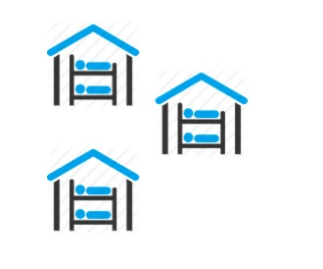

Submitted By

Divyansh Aggarwal (B15CS017)

Vishesh Mistry (B15CS040)

Revision History

|  |  |  |  |
| --- | --- | --- | --- |
| **Date** | **Version** | **Description** | **People** |
| 16 Jan 2017 | 1.0 | First draft | Divyansh Aggarwal  Vishesh Mistry |
| 1 Feb 2017 | 2.0 | Created Use-case and Activity diagrams | Vishesh Mistry |
| Created Sequence and Class diagrams | Divyansh Aggarwal |
| 4 Mar 2017 | 3.0 | Coded an iOS app which performs all the functions as required | Divyansh Aggarwal  Vishesh Mistry |

Table of Contents

1. Introduction 4

1.1 Purpose 4

1.2 Scope 4

1.3 Constraints 4

1.4 Assumptions and Dependencies 4

1.5 Definitions, Acronyms and Abbreviations 4

1.6 References 4

1.7 Organization of the Document 5

2. Overall Description 5

2.1 Product Functions 5

2.2 User Characteristics 13

3. Specific Requirements 13

3.1 Use case description 13

3.2 Supportability 18

Software Requirements Specification

# Introduction

## Purpose

The purpose of this document is to illustrate the requirements of the software – Hostel room allocation and management. The main purpose of this software is to automate the process of hostel room allocation in university hostels.

## Scope

The software aims at providing a mobile application for the convenient allocation of rooms fir the students as well as an equally convenient way of managing the process by the concerned authorities.

The students will be able to request for a room of their choice at the start of each academic year and also apply for a room change. The room allocation will be based on the gender, room availability and the preference of the students. The Hostel Management Committee will be able to process the requests.

This software will thus help to reduce the hassle generally involved in the process of room allocation. Moreover the details of the rooms of the students can thus be retrieved easily as and when needed.

## Constraints

The number of students who can simultaneously use the software will be limited by the server capacity. It also requires internet access for its use.

## Assumptions and Dependencies

The hostel room available and their capacities are known to the users. The students do not request a room on behalf of someone else without his/her consent. Users will provide legitimate information while signing up. The sever on which the database is stored is well secured.

The end user should have proper understanding of the software. Appropriate hardware must be available.

## Definitions, Acronyms and Abbreviations

|  |  |
| --- | --- |
| **Term** | **Definition** |
| User | All student hostellers, HMC |
| HMC | Hostel Management Committee |
| Students | 1st, 2nd, 3rd and 4th year UG students and PG students |
| UG | Under Graduates |
| PG | Post Graduates |

## References

[1] www.slideshare.net

[2] Roger S. Pressman, Software Engineering: A Practitioner’s Approach

## Organization of the Document

Section 2.1.1 talks about the functional requirements or the capabilities of the software and the functions that different users can perform through the software. Section 2.1.2 describes the other system hardware requirements and other requirements that must be met for the software to run efficiently and effectively. Section 2.2 gives the different users interacting with the software.

# Overall Description

## Product Functions

### Functional Requirements

1st year students will be able to view the rooms allocated to them. All the previous students will be able to request for a room of their choice at the beginning of the academic year and also apply for a room change. The HMC will either approve or decline the students’ requests. It will also be able to change the allocated rooms of students if needed.

#### Use-Case Diagram

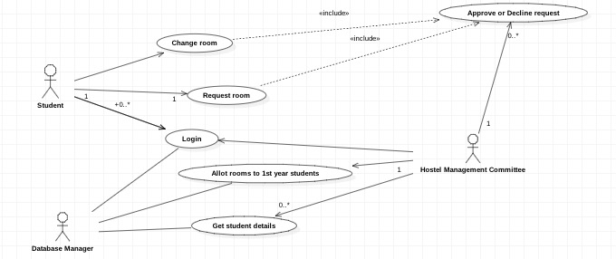

#### Class Diagram

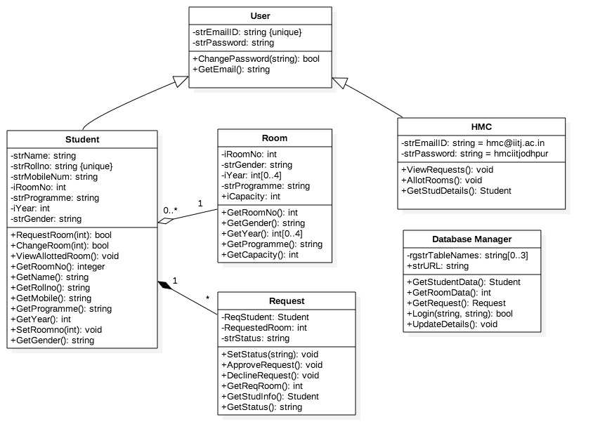

#### Sequence Diagram

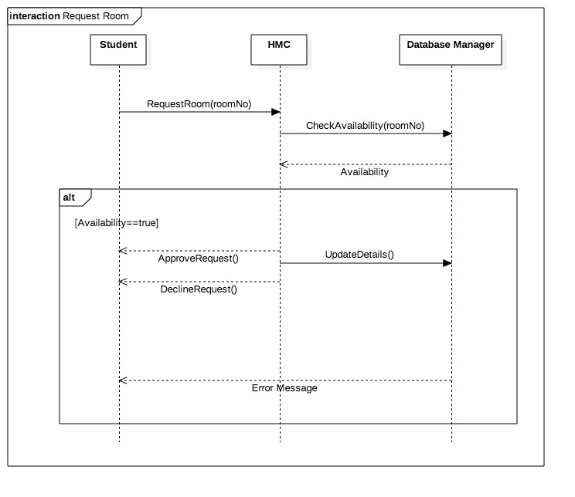

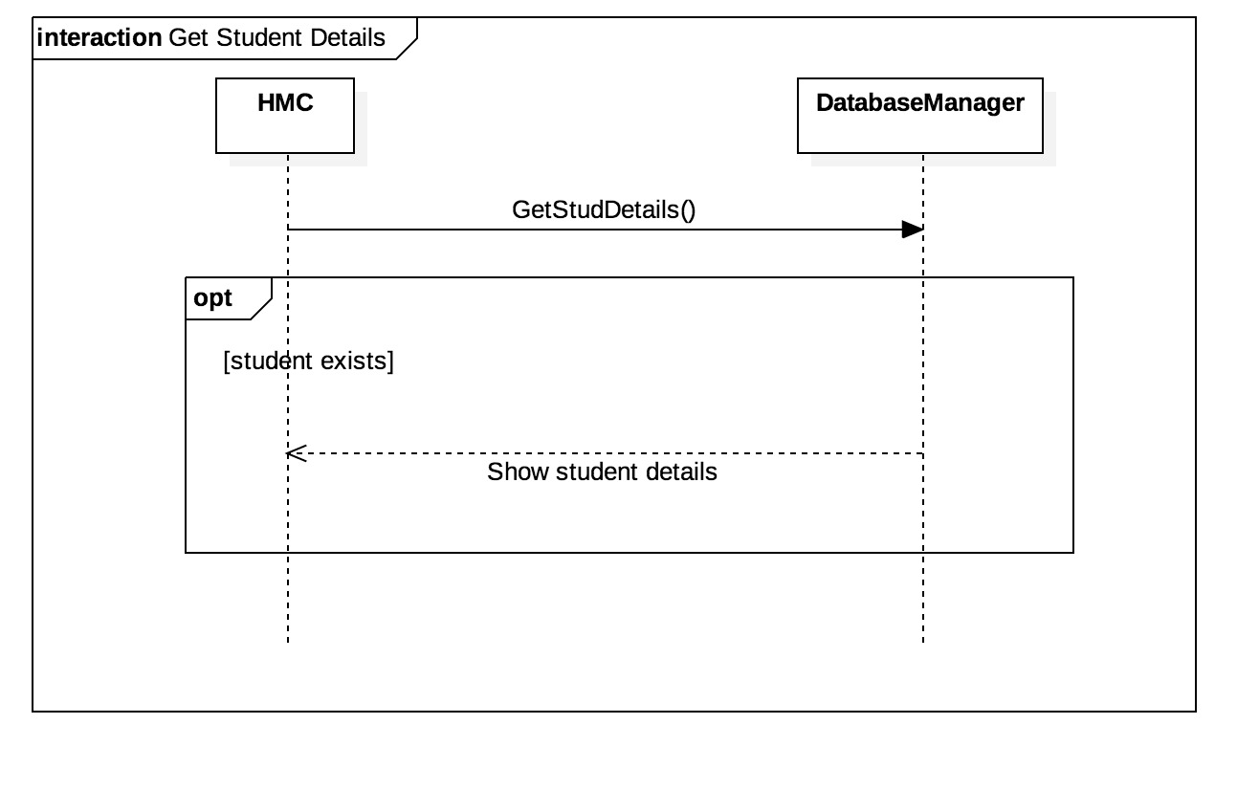

#### Activity Diagram

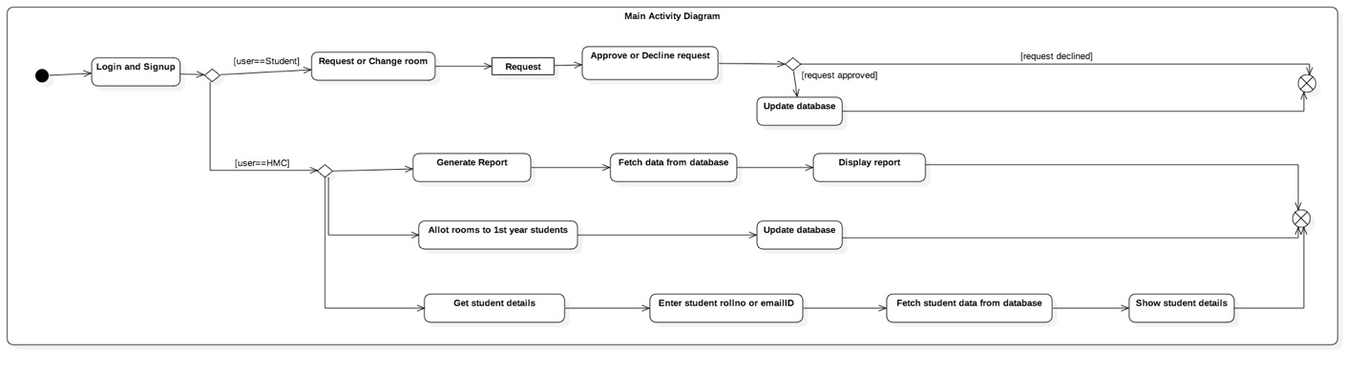

### Non-Functional Requirements

There should be internet access while using the software for all the users.

## User Characteristics

There are three types of users that interact with the system – the student hostellers, the HMC, and the CS team.

The 1st year students will interact with the software to view the rooms which will be randomly allocated to them. The previous year students will be able to request a particular room at the start of the academic year and also request for a room change.

The HMC will be able to process the requests by the students and will either approve or decline the requests. In addition, the HMC will be able to change the room of students if needed.

# Specific Requirements

## Use Case Description

### 

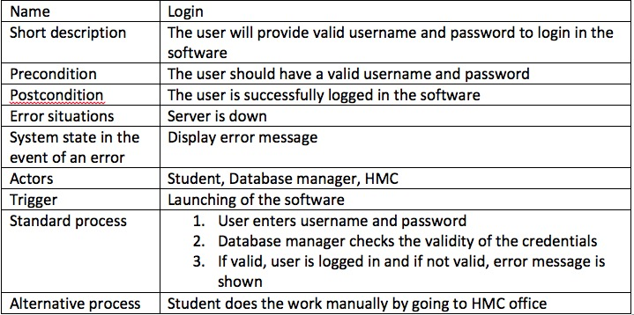

3.1.2

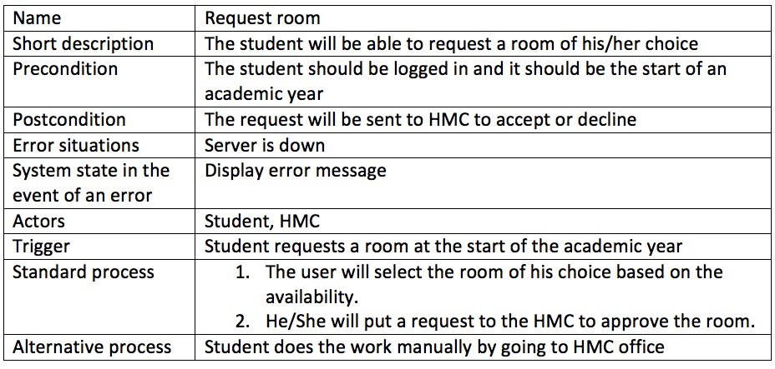

3.1.3

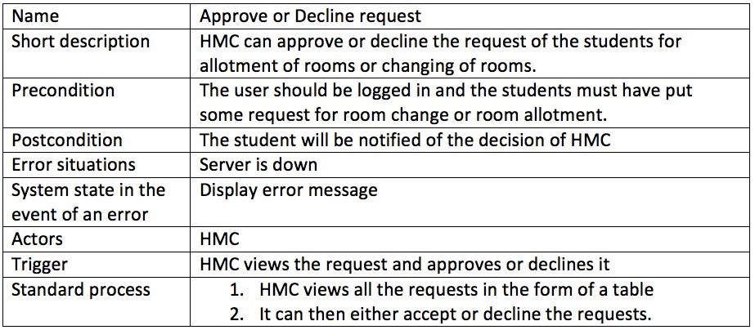

3.1.4

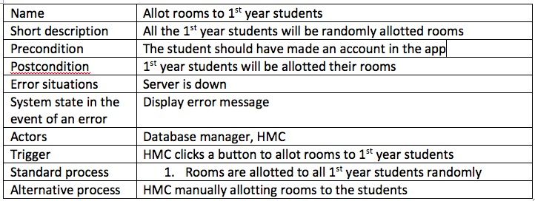

3.1.5

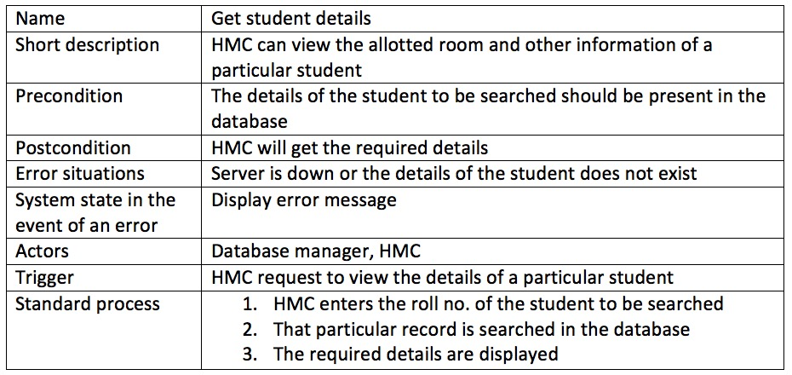

## Supportability

### Naming Convention

All code will be written as specified by the Hungarian Naming Convention.

## Design Constraints

### Software Language

All code is written in Swift 3.0 (using Xcode) and PHP.